1Lab Sheet 4: Shell Programming

Questions
1. Write a shell script to generate emails in the given format and write it into a file. Your script should accept sender and recipient email id’s and subject as command line arguments.
From: abc@domain1.com To: xx@domain.com Cc: yy@domain.com
Subject: Subject 1
This email is generated by my shell script.
Thanks and regards
S4 CSE student
Amritapuri
--->
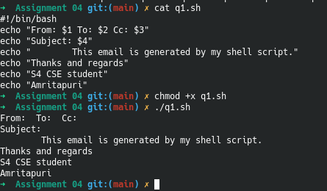
2. Modify Question 1 to allow user to enter text at the beginning of email content, by passing it as a command line argument.
--->

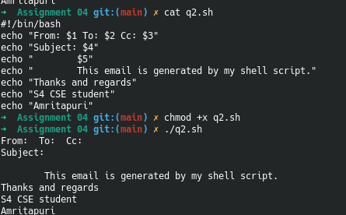
3. Write a shell script to print all the primes below a given number.
--->
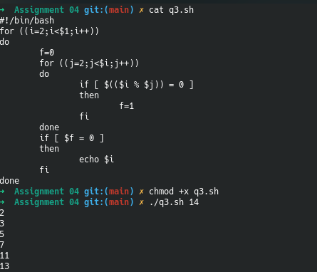
4. Write a shell script to print the first n Fibonacci numbers.
--->
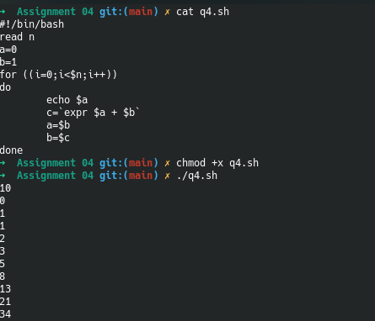
5. Write a shell script to generate a multiplication table.
a. Interactive version: The program should accept an integer n given by the user and should print the multiplication table of that n.
--->
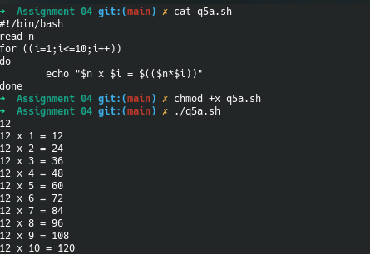
b. Command line arguments version: The program should take the value of n from the arguments followed by the command.
--->
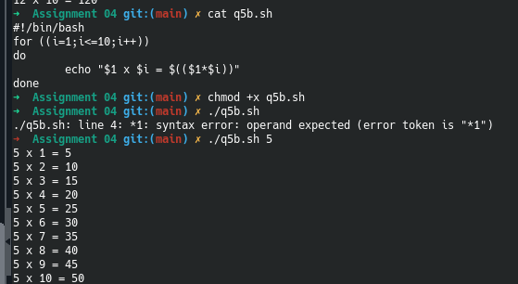
c. Redirection version: The value of n must be taken from a file using input redirection.
--->
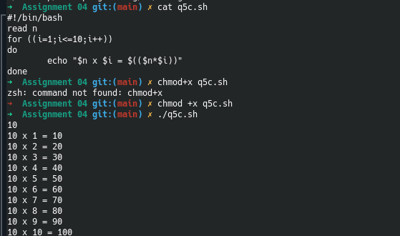
6. Using function write a shell script to find gcd of two numbers.
--->
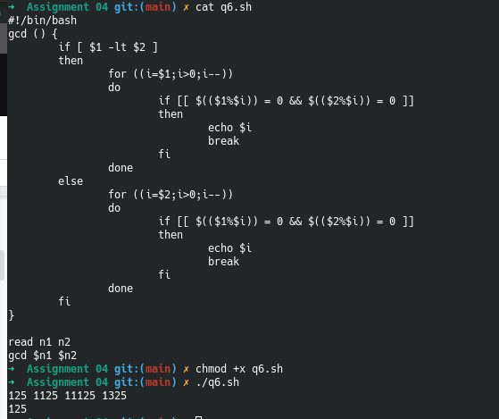
7. Using Recursion find factorial of a number
--->
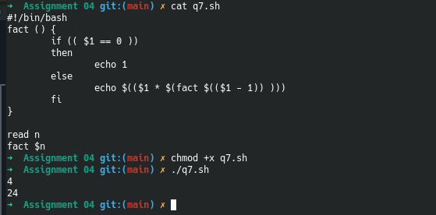

8. Write shell script to show various system configuration like:
a. Currently logged user and his long name
b. Current shell
c. Home directory
d. Operating system type
e. Current path setting
f. Current working directory
g. All available shells
--->
